
Al-Balqa Applied University
Prince Abdullah Bin Ghazi Faculty of Information & Communication Technology
Department of Computer Science
PARTY.JO
Wedding & Party Services Platform

FRD (FUNCTIONAL REQUIREMENT DOCUMENTATION)
Version 1.0

Presented by:
Hamzah Ghnimat, Mohab Omar, Qusai Alhaj

Supervised By:
Dr. Khalaf Khatatneh, Dr. Zaid Al-Laxmi

11/4/2026

TABLE OF CONTENT

TITLE PAGE………………………………………………………….1
INTRODUCTION…………………………………………………….3
DEFINITION………………………………………………………….3
IN SCOPE, OUT OF SCOPE…………………………………………4
1. FUNCTIONAL REQUIREMENTS……………………………….5
1.1Motivation……………………………………………………….?

2. FUNCTIONAL REQUIREMENTS (UML)………………………8

2.1 Use case (admin, client, couple)………………………………?
2.2 Use case (service provider)……………………………………?

2.3 Activity diagram (admin page)……………………………….?

2.4 Activity diagram (user page)………………………………….?

2.5 Activity diagram (service provider)…………………………..?

2.6 Architecture diagram………………………………………….?

SYSTEM USERS & ACCESS LEVELS……………………………15
3. BUSINESS PROCESSES & WORKFLOWS……………………16
3.1 Service provider log in………………………………………......?
3.2 Client/couple log in ……………………………………………..?
3.3 Reports……………….……………………………………..........?
3.4 photo ……………………………………………………….........?
3.5 ai…………………………………………………………….........?
3.6 offers……………………………………………………………..?
3.7 request a service…………………………………………………?

Introduction
This document provides a detailed description of all the functions and features that will be implemented on the parties.jo website.
This website will offer all the details and services related to weddings, events, or any other services the client wants. We will provide them with complete information about any service they choose and will organize all prices for weddings, events, and any other services. Hamzah, Mohab, and Qusai will create this website and submit it to the supervisors: Dr. Khalaf Khatatneh and Dr. Zaid Al-Lami, for our university, Al-Balqa Applied University.
DEFINITION
User login interface: This interface allows the customer, couple, service provider, or administrator to access their accounts when opening the website using their email address and password.
Admin Dashboard: The admin must have a dedicated dashboard with access to Reports, Services management, and full control over all website sections.
Admin Reports: When the admin logs in, a "Reports" button must appear showing all feedback and reports submitted by clients and service providers.
Service Management - Administrator: This section provides the administrator with access to all service providers, allowing he to accept or reject services.
Client Reports: Clients must be able to submit comments and suggestions, which are sent directly to the admin's Reports section.
Partner Logos: Display A box at the bottom of the page must automatically display logos imported from registered service providers.
Service Provider - Add Service: This section allows all service providers to add their services after the administrator approves their organization.
IN SCOPE, OUT OF SCOPE
Within the scope, this system helped us to gather all prices in one place, provide all services in one place, provide the customer with a comprehensive description on the website, provide customer service to help, provide offers and a photo gallery of all the events or weddings we have managed previously, in addition to artificial intelligence sections to help the customer submit suggestions, company logos to display all the companies we cooperate with, customer reports for the manager to improve the site, an administrative dashboard and approval system to help the manager evaluate the quality of services provided by service providers, then approve or reject them, and many other advantages.

Outside the scope:

1. Social media integration

2. Human resources or payroll management

3. Mobile application

4. Resource management: whether the service is old, new, or expensive

5. Payment system integration

Functional Requirements
The system must provide the client, couple, or service provider to see a login page at the top of the website upon opening it, where they can enter their e mail address and password. Upon returning, their email address will be displayed without needing to log in again. We want to create a unique manager account to offer different features. In addition, thy system must provide the client, couple, or service provider to see a “Description” section at the top of the website upon opening it, and for clicking a button to show a video explaining the site and an introductory paragraph. The system must create four sections on the homepage: one for men, one for women, one for service providers, and one for clients.
In the first men’s section, clicking a box will display car rental services, Hair salons, wedding halls, land rentals, restaurants, and suits. Clicking on any service in the list will display all the services offered by that provider. In the second women’s section, clicking a box will display Hair salons, restaurants, dress rentals, beauty services, henna halls, and photographers. Clicking on any service in the list will display all the services offered by that provider. In the third client section, clicking a box will display car rentals, hair salons, restaurants, farm rentals, hall rentals, party planning services and photographers. We want the customer, couple to see a “basket” at the top of the website, and when opened, it will display all the services they clicked on, along with the price and sales calculation.
The system shall display to the client, couple, or service provider to see an “Offers” section at the top of the website. When opened, it will explain all available offers and discounts on all services, if any exist, the service provider offering these offers, and information about wedding packages and any other packages. In addition, if the service provider clicks the button, an “Add” button will appear, allowing them to add any services that the client and couple might benefit from discounts or sales on. We want to create a small box to display our contact information in case the client wants any customer service, such as a WhatsApp number, phone number, and email address.
When the service provider section is clicked, the system shall display several pieces of information that they must answer, such as: the organization name, the owner’s or person’s name, email address, phone number, location/city, a picture of the organization and Logo. The system must create a login account for the manager. When they open their website, a “Reports” button will appear. Clicking this button will display all reports received from clients to help improve their website. Additionally, the system must create a “Services” button. This section will display all service providers and their information, and the administrator can approve or reject any service. We also want to create a “Reports” section so that clients can submit comments or suggestions and send their responses to the administrator’s reports section.
After the service provider opens their section and enters all the information, they will be taken to a page containing an “Add Service” option where they can add their service in the “Write” box. When the service provider opens their section, they will add all their services, and we will send them to the “Customers and Couples” section. We want a radio button to appear for each of the following services: car rentals, barbershops, wedding halls, land rentals, restaurants, suit sales, dress rentals, beauty services, henna salons, photographers, farm rentals, venue rentals, and party planning services. Clicking any radio button will select the service and place it in its appropriate section within the Men, Women, and client sections, and the service provider will enter all the service details in the written form.
We would also add a button at the top to display all photos related to any wedding or event we manage. We would like to add an AI-powered section. When you click this button, the AI will ask you to take a selfie, including your body and face, and will offer several suggestions regarding hairstyles, clothing, and weather conditions. We would like to display all logos in a box at the bottom of the page. These logos will be imported from the service provider who logs into their page.

Motivation
Our platform aims to simplify wedding and event planning by bringing all services into one easy-to-use system. Unlike platforms such as WeddingWire and The Knot, which mainly focus on listings, our platform provides a more personalized and interactive experience for clients, couples, and service providers. With features like categorized sections, a smart basket, special offers, and AI-powered recommendations, we offer a complete and efficient solution that makes planning easier and more enjoyable.

Functional Requirements (UML)

Use Case (admin, client, couple)
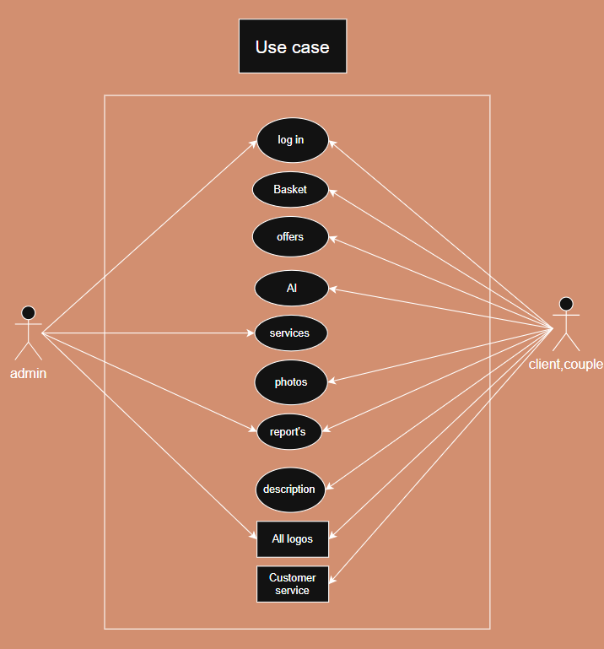
This example aims to showcase all the specialized services available to administrators, clients, and partners. Upon opening the website, the system should display the login page, services, reports, and all logos to manager. The couple or client will see the login page, Basket, offers, AI features, images, reports, description, all logos, and customer service. Expected outcome: The system should provide administrators, clients, and partners with a variety of services.

Use Case (service provider)
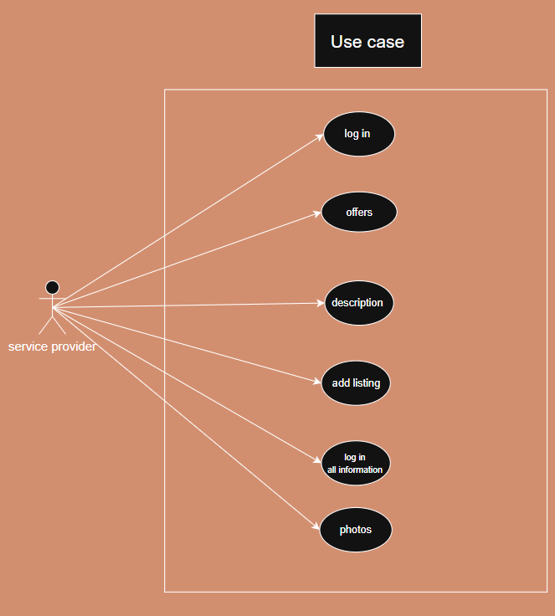
This example aims to showcase all the specialized services available to the service provider. Upon opening the website, the system displays the login page, offers, descriptions, and images. Clicking on the relevant section opens the login page to view all the information, and after administrator approval, Add listing. Expected Outcome: The service provider will be able to add their services easily and conveniently.

Activity Diagram (admin page)

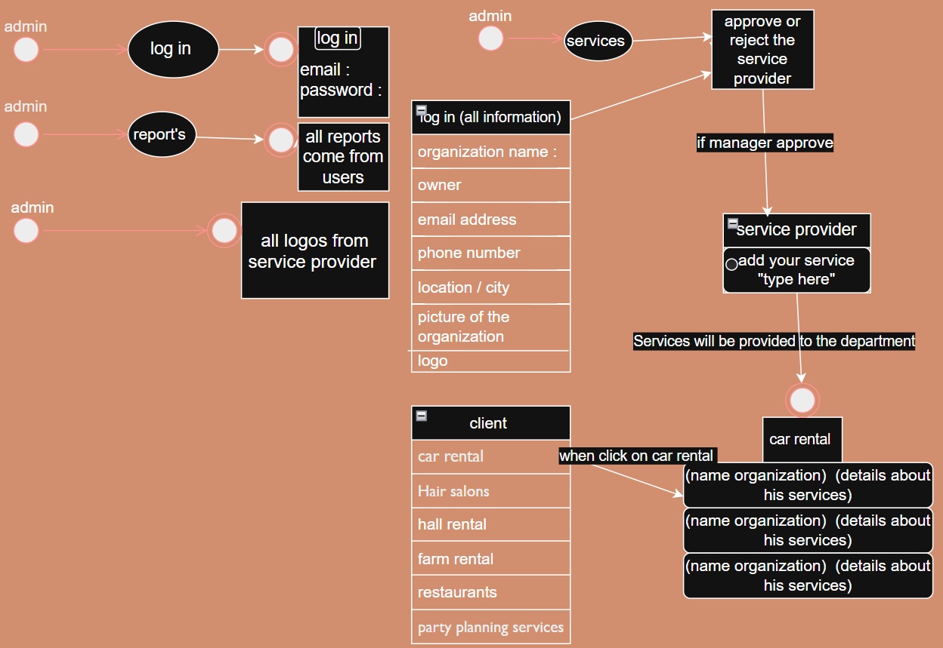

This activity chart aims to clarify the manager's tasks and workflow. When the manager logs in, the system should prompt for their email address and password. When the manager clicks on "Reports," the system should display all customer reports. The system should display all the manager's logos. When the manager clicks on "Services," the system should display all service provider requests, allowing them to approve or reject services. Expected Outcome: The manager will be able to manage all their services, approve service providers, and clearly define their website's workflow.

Activity Diagram (user page)

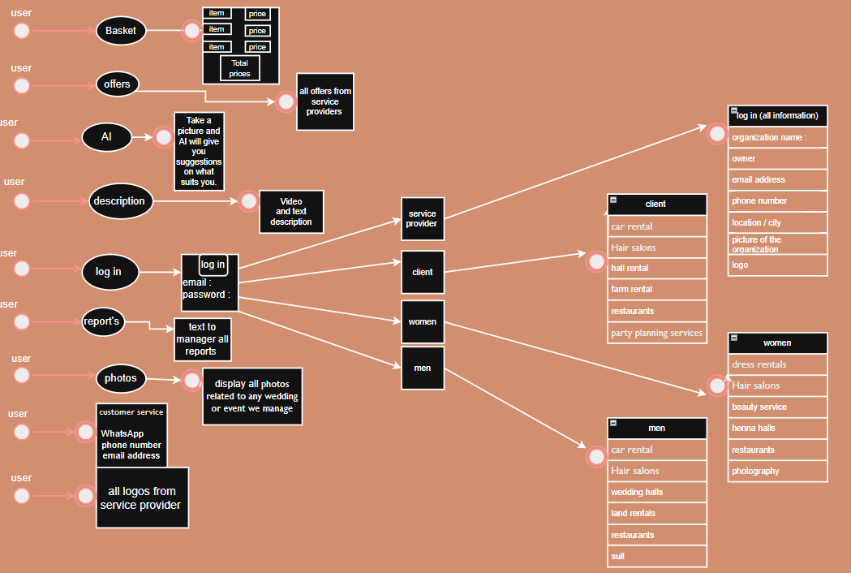

This activity chart aims to clarify the user's (client's or couple's) roles and workflow. When the user opens the website, the system should display the following: Login the system must ask to Enter email address and password. After logging in, four categories (groom, bride, client, and service provider) are displayed, each with its own services. Clicking on "Basket" should display all prices and product names. Clicking on "Offers" should display all offers and packages. Clicking on "Artificial Intelligence" should help the client provide suggestions on what suits them best. Clicking on "Description" should display a video and a description of the venue. Clicking on "Reports" should display a page to send a message to the manager regarding system improvement. Clicking on "Photos" should display all events or weddings we have previously managed. The system should display customer service for any assistance. The system should display all logos for the client to identify the company we collaborate with. Expected outcome: The system will make it easier for the customer to access all their service needs.

Activity diagram (service provider)

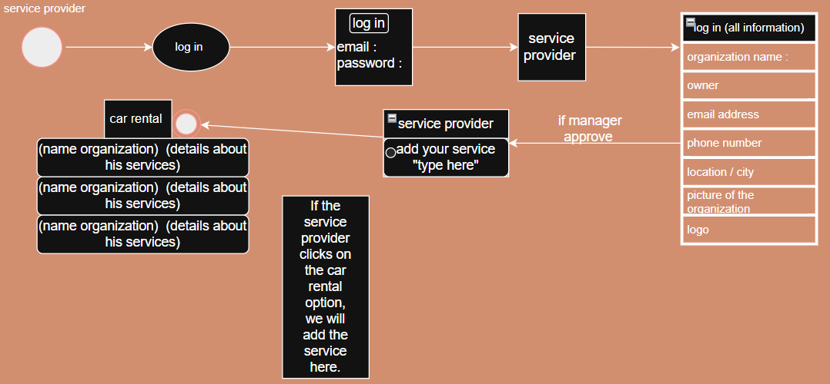

This activity plan aims to showcase all the services offered by service providers. Upon opening the website, the system displays a login page. Then, upon clicking on the relevant section, the system requests all information related to the organization. Once the information is submitted, it is sent to the administrator for approval or rejection. If the service is approved, an "Add to List" button appears, along with several “radio buttons” for each service on its website. Expected Outcome: The system should enable service providers to easily add their services.

Architecture Diagram
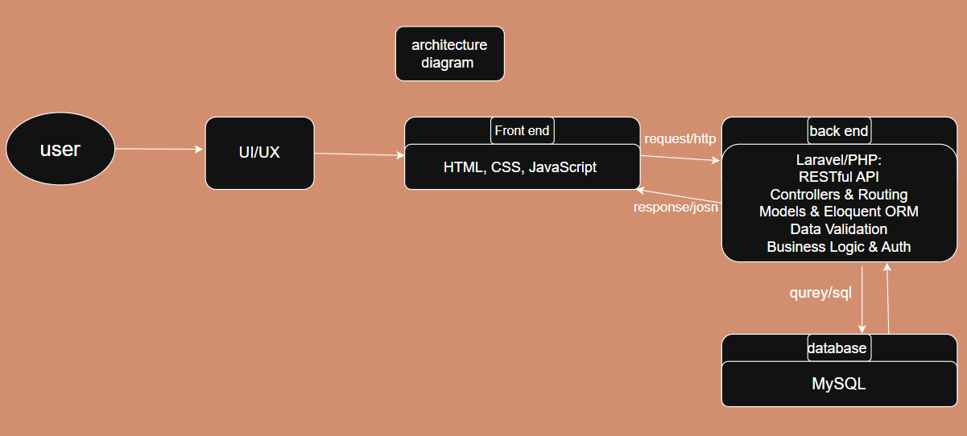
Back-end Layer:
- Develop server-side functionality using Laravel/PHP.
- Implement API endpoints for data handling.
Front-end Layer:
- Build the user interface with HTML, CSS, and JavaScript.
- Design user experience and UI interactions.
System Integration:
- Connect front-end with back-end via HTTP requests.
- Exchange data using JSON responses.
Database Layer:
- Manage data storage using MySQL.
- Write and execute SQL queries for data retrieval and manipulation.
Sequence Diagram – Party.Jo
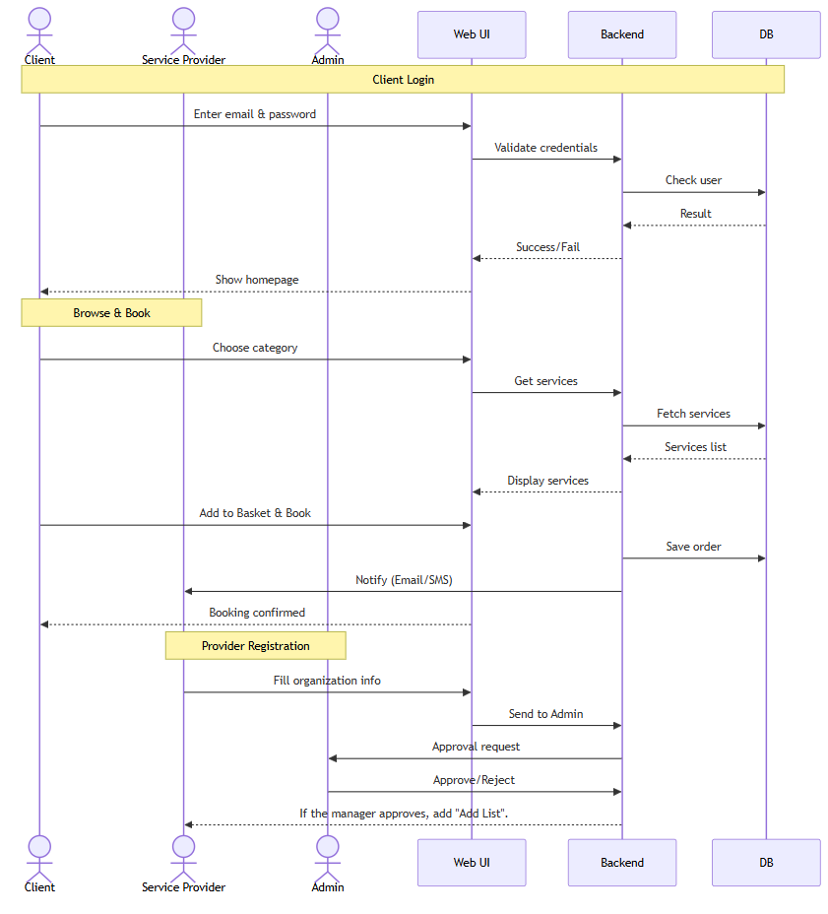Sequence diagram

System Users & Access Levels
 | admin | customer / couple | service provider
offers | ❌ | To view✅ | To add✅
Basket | ❌ | ✅ | ❌
AI | ❌ | ✅ | ❌
services | ✅ | ❌ | ❌
description | ❌ | ✅ | ✅
log in | ✅ | ✅ | ✅
reports | ✅ | ✅ | ❌
photos | ❌ | ✅ | ✅
All service providers | ✅ | ❌ | ❌
All logos | ✅ | ✅ | ✅
Approve / reject providers | ✅ | ❌ | ❌

BUSINESS PROCESSES & WORKFLOWS
Service Provider Log In
When the service provider opens the website, ask them to log in by entering their email address and password.
Upon accessing their section, the system will request information about the organization.
Send the requested information to the administrator in the "Services" section.
The administrator will decide whether to approve or reject the request.
If approved, the service provider will see an "Add List" option, along with "radio buttons" for each service on their website.

Client/Couple log in
When a client or couple opens the website, the system should display a login section.
Upon opening this section, the system should prompt them to enter their email address and password.
Afterward, a separate section is displayed for each category (groom, bride, client).
If a client opens their section, the services will be displayed based on the service provider.
Then, if the client clicks "Add" for any service, the service will be added to their Basket along with the price.

Reports
When a client or couple have a recommendation to the website, the system will display a "Reports" button.
When this section is opened, the system should display a message to the administrator.
The message will be sent to the administrator in the Reports section.
The administrator can then reply to any message.

offers
When a client or couple opens the website, the system should display the Offers section.
Display all offers based on the service provider.
The service provider has the same section, but for adding offers.

AI
When a customer or couple opens the website, the system should display the AI ​​section.
Upon opening this section, the AI ​​should ask the customer which service they would like (usually based on their body shape or facial features or hair cut).
The AI ​​will then ask you to take a selfie.
It will then offer you a service that suits your needs.

photo’s
When a client or couple opens the website, the system should display the Photos section.
Display all photos based on the client or couple.
When a client or couple uses our service and opens this section, they will find an "Add Photo" button.

Request a Service
The customer will open the website and see all the categories.
If they wish to access a category, the system will display all available Dedicated services to section.
If they select a service, a list of service providers will open, and the system should display all available services with their details and prices.
Then, upon clicking the submit button, the system will take the customer to their "Basket" and display all product names and their prices.
Then, upon clicking "Book" at the bottom, the system will ask the user to confirm their selection.
Afterward, the system will send notifications to the service provider on the website, as well as to their email address and phone number (for calls and messages), to inform them that they have received a request from the customer.

